**COME LEARN TO CODE AND CHANGE**

**THE WORLD... JOIN A GIRLS WHO**

**CODE CLUB!**

# WHAT IS A GIRLS WHO CODE CLUB?

Girls Who Code Clubs are meant for girls to join our sisterhood of supportive peers and rolemodels, and use Computer Science to change the world. When you join a Club, you will be able to learn from fun and simple online coding tutorials, build community through interactive activities, and learn about inspiring role models. You then work in teams to design and build a Girls Who Code Project that solves real world problems you care about through code!

# WHAT WILL I LEARN?

Our middle and high school Clubs encourage you to impact your community in a positive way through code. In order to build the skills you need to make an impact, you will learn how to code from our fun online tutorials and activities that will help you build animations, games, apps, and other things that you dream up! We have tutorials in Scratch, Python, Swift, HTML, CSS, and JavaScript.

# CAN I JOIN?

Yes! Whether you’re a beginner or a computer master, you’re invited to join the movement!

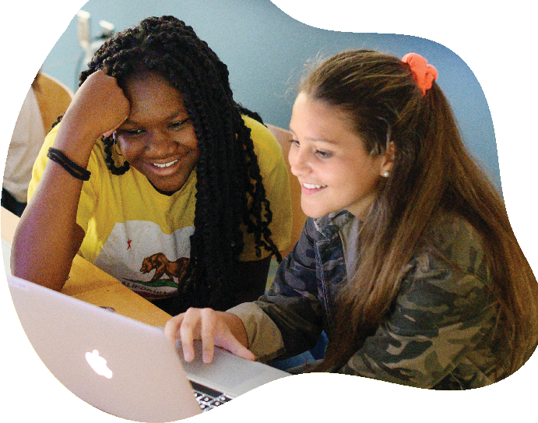

**POINT OF CONTACT: Daniel A. Sabol dsabol2@yonkerspublicschools.org DATES: TIMES: HOW TO SIGN UP:** [**https://hq.girlswhocode.com/login**](https://hq.girlswhocode.com/login) **Club Code: NY38697**

@GIRLSWHOCODE